Discussion Forum- [aiononline](https://forums.aiononline.com/topic/92-aion-memes/)

**Id**: 1

**Name:** Rubyvulpa-KT

**Comment**: Yes, we need a thread for this. Feel free to post all yer meemz, old or new, stolen or OC - but pls: make sure they're not too h8teful (as long as it's funny it's kay i guess). if it features art give that artist some recognition, cookies and backpats! aion related is 10/10 but just game related ones applicable to aion are kewl too

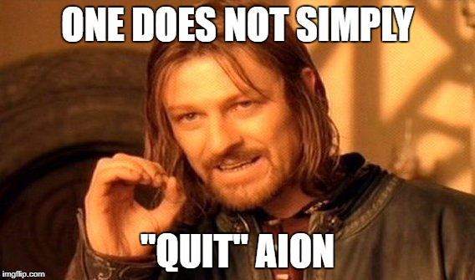

**Time**: August 10, 2017

**Like**: 0

**Id**: 2

**Name:** GenericUser592

**Comment**: my favorite



**Time**: August 10, 2017

**Like**: 3

**Id:** 3

**Name:** Ursa-KT

**Comment** am i salty about how Harvester cloth ended up looking in game? maybe. perhaps. who knows!

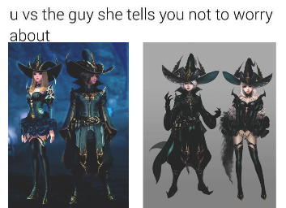:

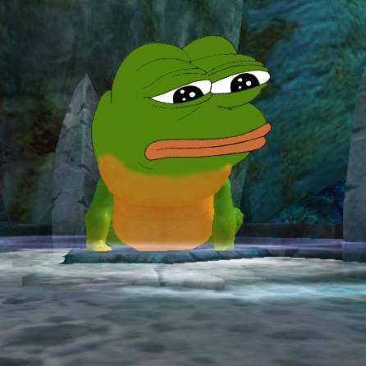

**Time**: August 10, 2017

**Like**: 3

**Id:** 4

**Name:** Rubyvulpa-KT

**Comment**: On 8/10/2017 at 0:26 PM, Hourglass-SL said: Imma steal this image for future purposes ;)



Time: August 10, 2017

Like: 0

**Id:** 5

**Name:** Kubei-DN

**Comment**: My daily life as a cleric



**Time**: August 10, 2017

**Like**: 3

**Id:** 6

**Name:** Cheesecake-DN

**Comment**: On 8/10/2017 at 3:35 PM, Kubei-IS said: My daily life as a cleric Sorclife



**Time**: August 18, 2017

**Like: 0**

**Id:** 7

**Name**: Nyali-DN

**Comment**: Need more inventory space! <:



**Time**: August 18, 2017

**Like**: 1

**Id:** 8

**Name**: 1s2F8B60-KT

**Comment**: I posted this in another thread but I feel like it would be a good addition to this one as well. It portrays my constant frustration with elyos clerics always being better than asmo clerics

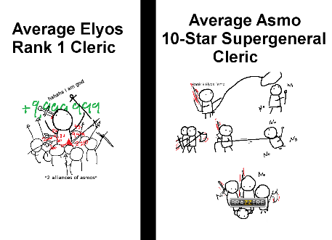

**Time**: August 24, 2017

**Like**: 3

**Id:** 9

**Name**: Aly-DN

**Comment**: ^ Feels like that some days, doesn't it? Lol

**Time**: August 24, 2017

**Like**: 3

**Id:** 10

**Name**: Nyali-DN

**Comment**:



**Time**: August 25, 2017

**Like**: 1

**Id:** 11

**Name**: Aly-DN

**Comment**:



**Time**: September 21, 2017

**Like**: 8

**Id:** 12

**Name**: Bryos-DN

**Comment**: Some repost from the old forums. You broke y nail? I will break your Balaurea!

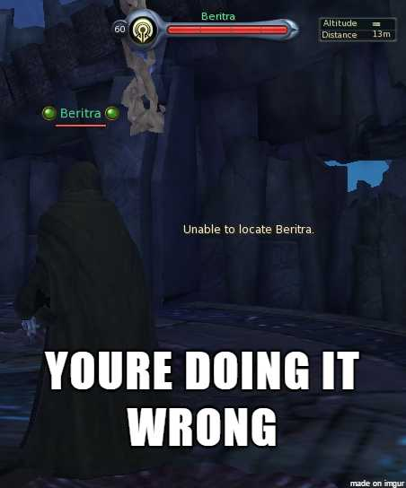

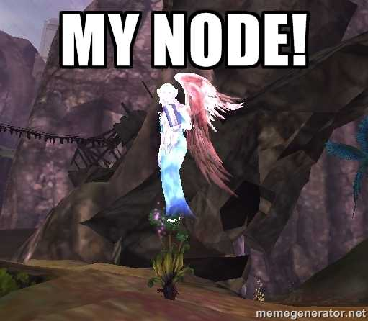

**Time**: September 21, 2017

**Like**: 8

**Id:** 13

**Name**: Magikarp-DN

**Comment**: why can't we just work together?

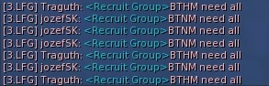

**Time**: September 21, 2017

**Like**: 1

**Id:** 14

**Name**: Aly-DN

**Comment**: On 9/21/2017 at 0:19 PM, Bryos-TM said: ^ This one made me laugh. So true. So freaking true!



**Time**: September 21, 2017

**Like**: 3

**Id:** 15

**Name**: Kaeta-KT

**Comment**: On 9/21/2017 at 10:18 AM, Nyinu-KR said: This is my every day life in Aion. It mem leaks and then crashes, between 30 minutes (lots and lots of people and no shift+f12ing), and perhaps 6 hours (off soloing alone). Then I have to force-murder the aion.bin process and restart. I estimate I get about 2 hours on average. And I have to restart my computer every 2-3 days from the +10% extra memory usage that gets tied up. Sure, I could buy extra RAM, or I could buy a new computer. But not worth it for a single game



**Time**: September 22, 2017

**Like**: 0

**Id:** 16

**Name**: Nyali-DN

**Comment**: ^ Feels like that some days, doesn't it? Lol

**Time**: September 22, 2017

**Like**: 0

**Id:** 17

**Name**: Aly-DN

**Comment**: Ye... especially those how make it a huge deal on LFG and the next day they are still online. lol

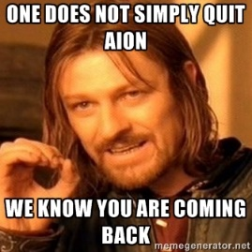

**Time**: September 22, 2017

**Like**: 2

**Id:** 18

**Name**: Vantheria-DN

Comment:

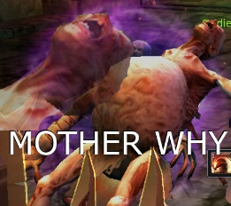

**Time**: September 23, 2017

**Like**: 1

**Id:** 19

**Name**: Vince-DN

**Comment**: *Cracks Knuckles* Alright, I knew this thread was coming eventually. Time to break out the stash.

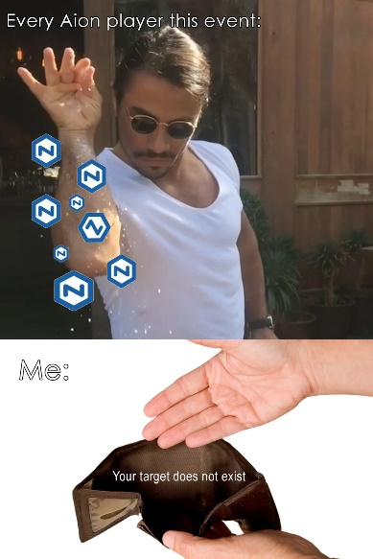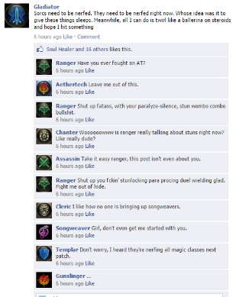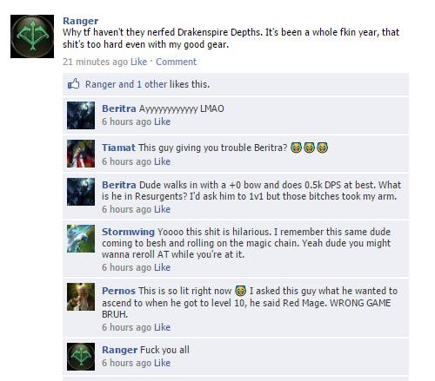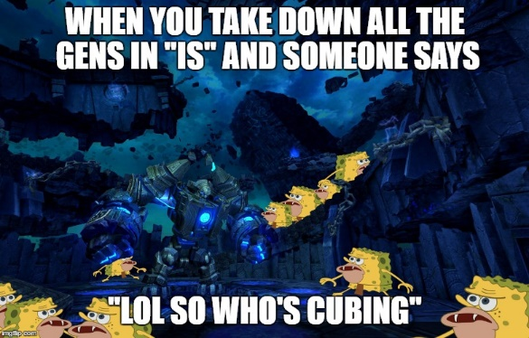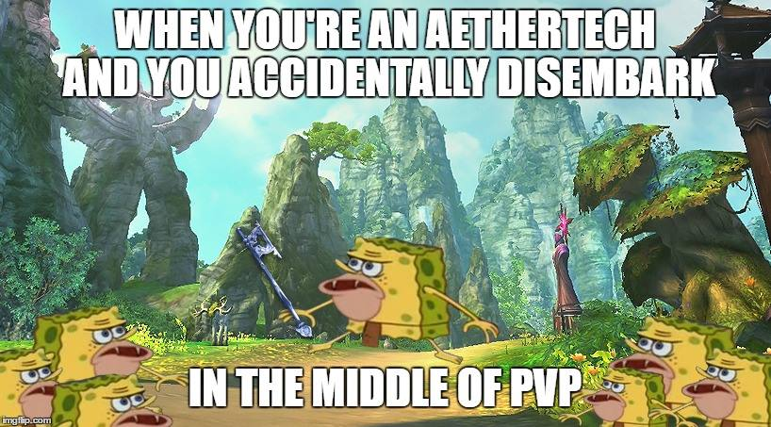

**Time**: October 3, 2017

**Like**: 5

**Id:** 20

**Name**: Bryos-DN

**Comment**: The class Facebook posts as nyerking gold.

**Time**: October 3, 2017

**Like**: 0

**Id:** 21

**Name**: Vantheria-DN

**Comment**: Those are all amazing, but that disembark AT one is too real. :(((( lmaooo

**Time**: October 3, 2017

**Like**: 0

**Id:** 22

**Name**: Andregark-DN

**Comment**: Credits goes to me and boring Monday afternoons 8)

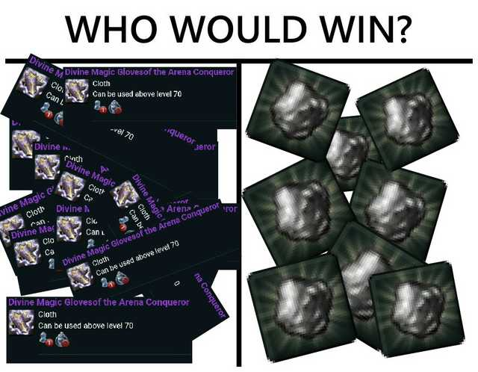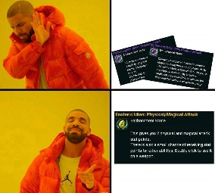

**Time**: October 3, 2017

**Like**: 3

**Id:** 23

**Name**: Ursa-KT

**Comment**: hello, i'm gonna dump some shitty oc i made once again And this one is special dedication to Bastion of Souls:

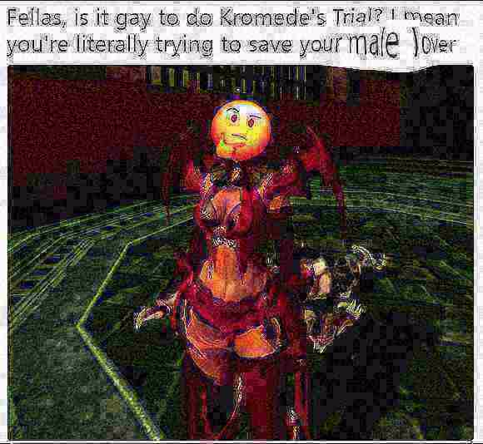



**Time**: October 3, 2017

**Like**: 3

**Id:** 24

**Name**: Vantheria-DN

**Comment**: That Kromede one gave me a good chuckle. xD

**Time**: October 3, 2017

**Like**: 0

**Id:** 25

**Name**: Vince-DN

**Comment**:



**Time**: October 7, 2017

**Like**: 1

**Id:** 26

**Name**: Voynich-KT

**Comment**: For users before Aion 4.8!.



**Time**: October 3, 2017

**Like**: 5